TEACHER PROGRAM

WSPSSA
ANNUAL ZONE CROSS COUNTRY

Wednesday 26th May 2021
Timbrell Park
Five Dock

WSPSSA Spectator/Teacher
Sign In/Out
QR Code

Please follow the instructions
outlined on the form

ZONE CROSS COUNTRY JOB CHART

Convener:
Courtney Avramides – 0433 391 006

Job | Official | School
Announcer | Greg Blundell | Homebush
Recorder | Natalie Armstrong | Summer Hill
Recorder | Vic Koutsoufis | Wentworth Point
Judge | John Tran | Haberfield
Judge | Michelle Seers | Homebush
Judge  (Walk to Recorders) | Lucy Winters | Croydon
Starter | Suzanne Curteis | Haberfield
Starter Marshal | Jenny Boyle | Abbotsford
Starter Marshal | Elisa Stanizzo | Russell Lea
Starter Marshal | Maggie Price | Strathfield North
Course Marshal (1) | Tyson Destefano | Concord
Course Marshal (2) | Wendy Stead | Burwood
Course Marshal (3) | Lily North | Dobroyd Point
Course Marshal (4) | Doris Hoang | Croydon Park
Course Marshal (5) | Georgina Christaki | Marie Bashir
Course Marshal (6) | Liam Wilson | Five Dock
Course Marshal (7) | Kirsty Sydenham | Ashfield
Course Marshal (8)  Tracking | Alison Waugh | Concord West
 | Isabel Braga | Enfield
 | Hamish Tranter | Mortlake
 | Fiona Donnelly | Summer Hill
Course Marshal (9) | Josephine Barron | Newington
Course Marshal (10) | Yena Han | Strathfield South
Course Marshal (11) | Annette Creighton | Victoria Av
Course Marshal (12) | Steve Smith | Homebush West
Course Marshal (13) | Ferda Adar | Newington
# All Course Marshal areas are marked.
Please go to designated marshal area on course.
PROGRAM OF EVENTS
(Commencing at 11:00am)

11:00am – Walk the course
11:45am – First race to start
Race 1 – 8/9 years Girls (2km)
Race 2 – 8/9 years Boys (2km)
Race 3 – 10 years Girls (2km)
Race 4 – 10 years Boys (2km)
Race 5 – 11 years Girls (3km)
Race 6 – 11 years Boys (3km)
Race 7 – 12/13 years Girls (3km)
Race 8 – 12/13 years Boys (3km)
Approximately 2pm – Cross Country Carnival Finishes

Please note:
- There are no set times for each race.
- Children will walk the course at approximately 11:00am
- First race will commence at 11:45am
- Races will be run after each previous race has finished.

IMPORTANT INFORMATION

- Suitable footwear must be worn – NO SPIKES.
- Competitors must be members of the Zone Team.
- The first 6 place getters in each event will represent the Western Suburbs Zone at the Sydney East PSSA Cross Country Carnival on Friday 11th June 2021 at Miranda Park, Miranda.
- The first 8 place getters in each event will receive ribbons. 7th and 8th will be reserve runners. They will not attend Regional unless notified by the Convener.

MAP – WITH COURSE MARSHALS

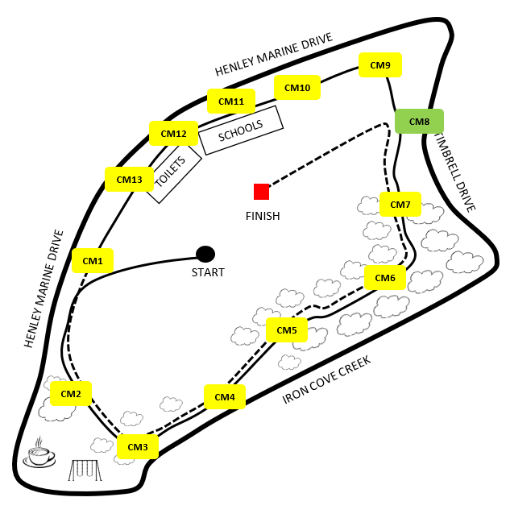

MAP – WITH COURSE MARSHALS

All course marshals are to
- Use your first aid kit (that you bring) to help participants requiring medical assistance. You can contact Courtney on her mobile if further medical assistance is needed.
- All participants should have puffers on them if they are asthmatic.
- Make sure that participants are following the correct path and aren’t taking short cuts.
- Inform any general public that there is a cross country carnival today and to take care along the path.
Any additional concerns for a course location are mentioned below
CM 1 | - Direct students onto the path  - Direct students around their 2nd/3rd lap  Seat already there.
CM 2 | Seat already there.
CM 3 | - Supervision is limited due to tree cover
CM 4 | - Supervision is limited due to tree cover
CM 5 | - Supervision is limited due to tree cover  Seat already there.
CM 6 | - Supervision is limited due to tree cover
CM 7 | - Very close to the road
CM 8 | - Spotters for the 2/3km race. Keeping track of who is in the lead so no one does extra laps.
CM 9
CM 10 | - Close to the road.  - Keep spectators off path.
CM 11 | - Close to the road.  - Keep spectators off path.
CM 12 | - Close to the road.  - Keep spectators off path.
CM 13 | - Close to the road.  - Keep spectators off path.

2KM CROSS COUNTRY MAP

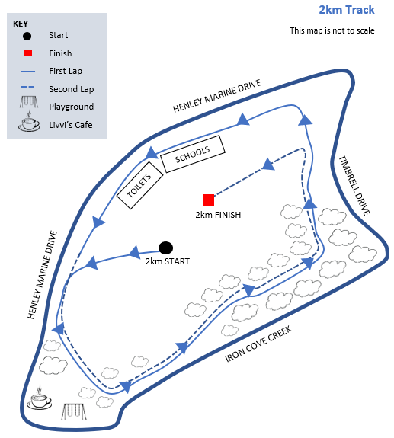

3KM CROSS COUNTRY MAP

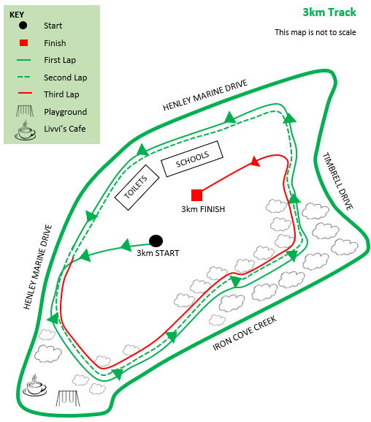

TEACHER PROGRAM

