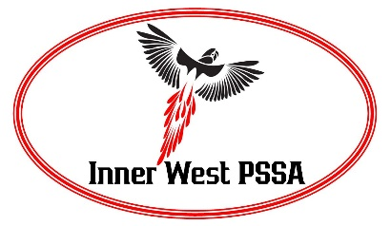

School Sport Inner West PSSA Head Injury Recognition and Referral Form

General Information
Player Name: Date of Birth:
Date: Time:
School: Sport:

The injury occurred due to;
Direct head blow or knock
Indirect injury to the head (ie Whip lash)
No Specific injury observed
Any Red Flags, as outlined in the Concussion Recognition, or potentially serious structural head and/or neck injury call an ambulance. Inform Principal. Call Incident Report and Support Hotline 1800 811 523
Removal from Play
If any of the following are observed or reported, the player must be immediately removed from play/training and referred for assessment by a medical Doctor. They are not
to return to training/playing that same day.
Yes No
Lying motionless on the playing surface
Slow to get up after a direct or indirect hit to the head
Disorientation or confusion
Blank or vacant look
Balance Disturbance
Unusual behavior changes for the player
Facial injury after head trauma
Memory Impairment (i.e. Memory assessment completed)
Player reports or displays any other concussion symptoms
Please List:
If player reports no to all of the above, give them the Heady Injury factsheet and advise that they still need to be monitored for 24-48 hours as signs and symptoms may emerge up to 48 hours after the impact.
_______________________________Public School (member school of Inner West PSSA)
Teacher Contact Name: Contact Number:
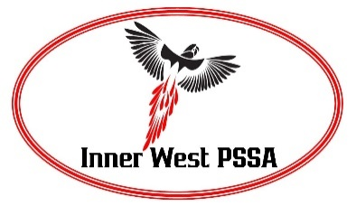

Medical Assessment and Clearance – To be completed by a Medical Doctor
Dear Doctor,
This player, ___________________________________ has been referred to you with suspected concussion. It is Inner West School Sport PSSA policy that all players with a suspected concussion or head injury must be assessed by a Medical Doctor as soon as possible after the impact before returning to learn/play. Please refer to the Concussion in Sport Guidelines https://concussioninsport.gov.au/resources
Any player diagnosed showing signs and/or symptoms of concussion must follow a Graduated Return to Play (GRTP) program, with further medical assessment if symptoms return.
If the Sporting Body has no mandatory period of time that the player must be withheld from play, the exclusion is based on the individual’s recovery as managed by their medical practitioner. Following Sport Medicine Australia’s concussion guidelines regarding a more conservative approach to Children and Adolescents, School Sport Inner West PSSA recommends an initial 48 hours cognitive and physical rest prior to graduated return to learning/play activities. They should be able to attend school symptom free before commencing GRTP and the protocol should be extended so that the player does not return to collision/contact activities less than 14 days from the resolution of all symptoms.
Initial Assessment
I have assessed the player and understand the information provided and approve them to begin a graduated return to play.
Practioner Name:
Signed:
Date:
Clearance Approval
Once the player has competed the first 4 stages of GRTP without any recurrence of the symptoms, a second consultation is required to clear the player for full training/match play. (Particularly relevant for Basketball, Rugby (all codes), Australian Rules Football, Football (Soccer), Netball, Cricket).

I have assessed _____________________________________ (players name) following the head injury sustained on the __/__/____ and approve them to return to full contact training and, if no recurrence to symptoms, they may return to match play as of __/__/____.
Practitioner Name: Medical Practice Stamp
Signed:
Date:

